The Effect of Caffeine on the Heart Rate
Students Name
Institutional Affiliation
Course
Date

The Effect of Caffeine on the Heart Rate
Introduction
Caffeine is one of the stimulant drugs that speed up the message travelling between the body and the brain. Caffeine is found in the leaves, seeds and nuts of various types of drugs, for example, coffee, tea and cocoa. The level of caffeine in different products varies from one product to another. Caffeine affects the users differently based on; weight, size and health, whether the individual is used to it, the amount of caffeine taken, whether there’s any drug accompaniment. It is also important to note that high levels of caffeine may lead to an increased heartbeat (Soares et al., 2017). It may also lead to altered atrial fibrillation in young generations who consume high levels of caffeine.
The data for this study was obtained from an examination of four young college men of ages between 19-20 years who took part in the study to show the effects of caffeine on the heart rate. The volunteers performed a one-mile walk with a zero incline and at a constant speed of 4.5mph. The data from the study were gathered for three days, and different participants were to perform the exercises upon waking up and without consumption of food. The fasted state among the individuals would, therefore, seek to provide accurate results as possible. The data was then gathered immediately upon the completion of the exercise needed. The individuals performed with no caffeine on the first day, a cup of black coffee on the second day and two cups of coffee on the third day before performing the exercises, respectively.

 | Day 1 | Day2 | Day3
Participant 1 | 0 cups of coffee | 1 cup of coffee | 2 cups of coffee
Participant 2 | 0 cups of coffee | 1 cup of coffee | 2 cups of coffee
Participant 3 | 0cups of coffee | 1 cup of coffee | 2 cups of coffee
Participant 4 | 0 cups of coffee | 1 cup of coffee | 2 cups of coffee

Once the data was compiled it was noted that;
A single cup of coffee increased the heart rate in all four persons slightly. The using up of two cups of coffee caused a more significant increase in the heart rate in all four persons. Therefore, caffeine has an effect on the heart rate fluctuations when it is consumed during or before an exercise at either a very moderate or light pace. In conclusion, all four persons indicated an increase in the maximum heart rate after taking caffeine. Each time the amount of caffeine increases the heart rate showed a positive deviation and increased as well.
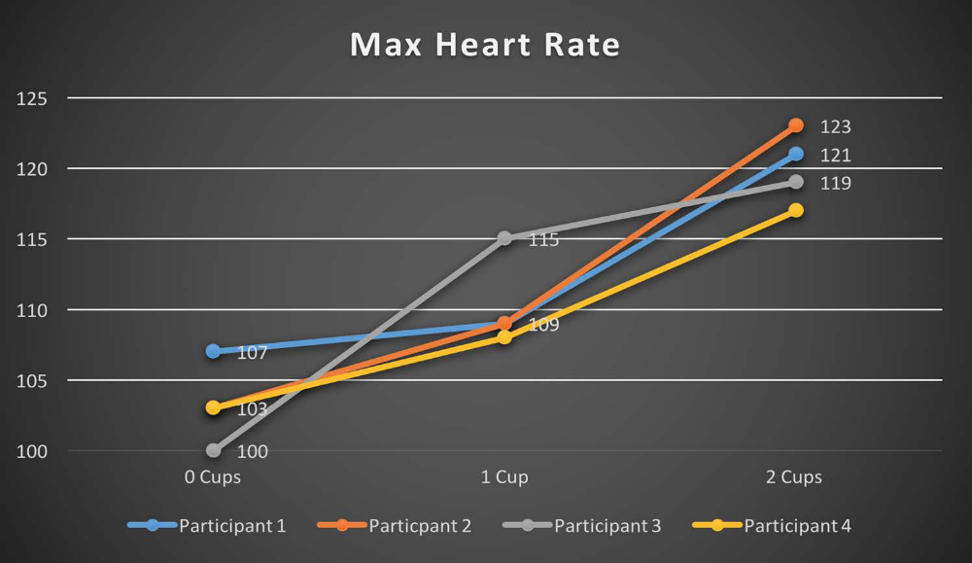
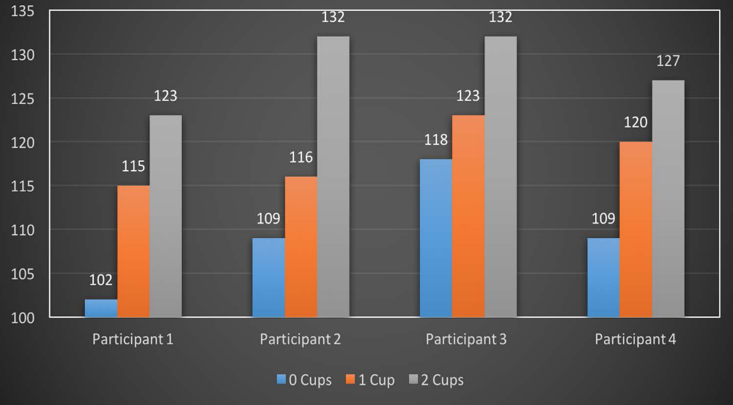
Through the evaluation of the above data, I would, therefore, acknowledge the alternative hypothesis since the study and evidence above lead me to believe that the caffeine in coffee increases the heartbeat rate with mass and frequent consumption. Hence caffeine is a stimulant drug in the body system, and with increased use, it can lead to harmful effects, for instance, the increased and altered heartbeat rate. Thus this could lead to the likelihood of one of the users suffering from a heart attack (Hajsadeghi et al., 2016). As a result, I would neglect the null hypothesis since the research states that coffee affects the heart rate. The reverse causation does not, therefore, make sense since ones increased heart rate does not make him or her drink caffeine.
Recommendations
Despite the empirical data evidence on the effects of caffeine on users that is adolescents, children and adults; the following could assist in lowering the impact of the level of caffeine on the body.
- The deployment of qualified experts to educate and inform the public on the effect of caffeine on their health and impact of high levels of caffeine on the body tissues and the heart.
- The drinks having caffeine must not be sold to underage that is students and children.
- The parents and guardians should be educated and informed on the indirect effects of caffeine on the health, and thus they should suggest the use of alternative beverages to those rich in caffeine.
Conclusion
Too much consumption of caffeine can lead to other side effects such as the propensity to ignore the caution signs when the body is tired and also sleep deprivation. It should also be noted with concern that caffeine does not stock up power nor prevent emotional tiredness; sleep and food are the only medications for these (Grgic et al., 2019). People who also seek to quit caffeinated drinks would face several challenges, i.e. the side effects of these persons were used to taking large amounts of caffeine. Some of the symptoms of withdrawal from caffeine include irritability, nausea, muscular tension, nervousness, constipation and headaches.

References
Grgic, J., Mikulic, P., Schoenfeld, B. J., Bishop, D. J., & Pedisic, Z. (2019). The influence of caffeine supplementation on resistance exercise: A review. Sports Medicine, 49(1), 17-30.
Hajsadeghi, S., Mohammadpour, F., Manteghi, M. J., Kordshakeri, K., Tokazebani, M., Rahmani, E., & Hassanzadeh, M. (2016). Effects of energy drinks on blood pressure, heart rate, and electrocardiographic parameters: An experimental study on healthy young adults. Anatolian journal of cardiology, 16(2), 94.
Soares, R. N., Schneider, A., Valle, S. C., & Schenkel, P. C. (2017). Regular physical activity increases the systolic blood pressure response to acute caffeine ingestion in nonhabitual caffeine consumers. Journal of Caffeine Research, 7(2), 53-58.

